Jin Lee
11/22/2020
MGMT 140
Final Concept Report
1. Your Evolving Business Concept
OutReach marketing is supposed to overcome changes in industry and market structure. This would include strategic innovations because no matter the industry, all businesses need marketing to establish their brand and reach their targeted demographic, especially in the age of social media to the age of the internet and social media. I consider my business to be a duplication and synthesis of other ideas, but OutReach will provide a large range of services. OutReach provides market consulting, market research, social media design & training, website development, marketing packages, and our Jin’s 100 step to Success program catered exclusively to each business to establish their own unique presence. Our goal is set our clients apart from their competition (highlight traits) what sets them apart. There is never a shortage of businesses as entrepreneurship is quickly growing. There is a limit to how much clientele marketing firms can take on, and we are open nationally.

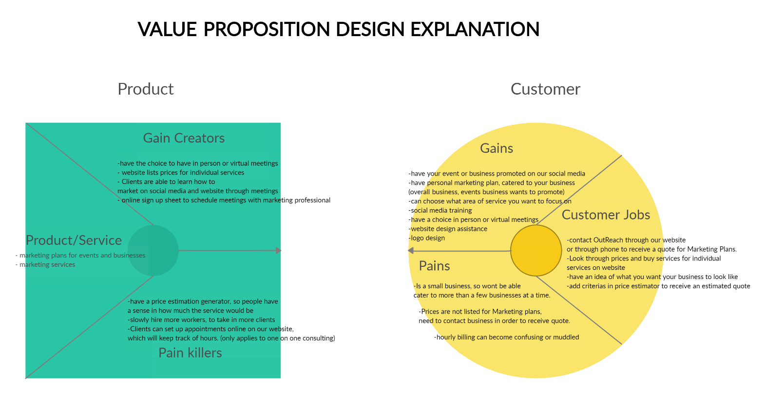
4. OutReach’s legal structure would be an LLC. This would be an appropriate structure for OutReach because we would receive the tax benefits as partnership and have limited liability. This legal structure is stable for a marketing firm, unlike sole proprietorships and partnerships. Also, marketing firms already need to keep in mind laws and regulations, like advertising regulations and promoting prices. I would have to do it either way in a partnership or corporation.
5. I would first trademark the name OutReach as a marketing firm and my logo, so people will not use my likeness for profit. Then I would need to patent my marketing process, Jin’s 100 steps to success, which is a template that can be molded for different types of businesses.
6. OutReach will help raise money and donate to struggling small businesses. Since OutReach is a marketing firm, we are indebted to small businesses. Small businesses need to succeed for marketing firms to succeed as well. It is our goal is to help our potential or existing clients flourish and thrive. Also, OutReach takes pride in our labor practices, we believe in diversity and providing a safe space for our team. We believe in raising each other up as a community.
7. To start my business, I would need about $50,000 for the first year. This includes office rent, software, internet, business utilities, insurance, legal and accounting fees, computers, etc. This does not include wages and salaries. I plan on financing my venture through debt financing from commercial banks/grants and venture capitalists. I will put in about $10,000 and receive bank loans and grants, since it is not a high-risk business. I would need a long-term loan of $40,000. Although my business is not high risk, I would also look for a venture capitalist. Marketing is a well-established industry, and my team would all have relevant experience in establishing a marketing firm, therefore venture capitalists are able to trust in a high return.
8. I am looking for people that are better than me, who have traits and talents that are different from mine to fulfill different roles within the company. I would like a risk taker and visionary for a “partner” or “stockholders” (because we are an LLC), because I carry out the logistic role. I would also like people who are professional web designers or graphic designers, and market researchers to join my team. Traits that I am looking for is creativity, confidence, determination, time competence, thoroughness, initiative, and the ability to make decisions quickly.
People would want to join our firm because we allow for creative freedom. Our clientele would range in different businesses, so our team would be able to work with all types of industries. I am looking for individuals who are willing to take creative risks. I would be a leader that encourage them to think out of box and would not penalize them for “failures” because we are all still learning.

